
DRAFT
EY Maritime Cyber Hub (EY MCH)
Sep 2025
Subject guideline: IACS E27/Rev.1 2023
Report ID: EYMCH-COMP/Circ.1-IMO MSC-202505-1.1
Report type: Public report
Report on Compliance Trend
Revision History

Version | Revision Date | Description | Created by
1.0 | 30 May 2025 | Initial Release | EYMCH Korea office
1.1 | 09 June 2025 | Revision made as per the request of the classification society | EYMCH Korea office

Table of contents `
1. Introduction 3
1.1 Purpose 3
1.2 Methodology 3
2. Scope of applicability 4
2.1 Vessels within the scope 4
2.2 Computer-based system within the scope 5
2.3 Device in the same Security Zone as the applicable computer based system 8
2.4 Exclusion based on Risk assessment 9
3. Definitions & Abbreviations 11
3.1. Definitions 11
4. Approval Porcess 14
4.1 Individual product approval process 14
4.2 Type Approval process 18
5. Requirements 19
5.1 System Requirements 19
5.2 Secure Development Lifecycle requirements 19
6. Documents 21
6.1 Computer Based System asset inventory 21
6.2 Topology diagrams 21
6.3 Description of Security capabilities 21
6.4 Test procedures of security capabilities 21
6.5 Security configuration guidelines 21
6.6 Secure development lifecycle 21
6.7 Plans for maintenance and verification 22
6.8 Information supporting incident response and recovery plans 22
6.9 Management of change plan 22
6.10 Test reports 22
7. References 23
Appendix 25

1. Introduction

1.1 Purpose
(추후 작성 예정 E26 + E27 + ClassNK)

This report has been developed to analyze how key stakeholders in the maritime and shipbuilding industry-namely shipowners, shipbuilders, and equipment suppliers-should respond to the evolving cybersecurity requirements outlined in MSC-FAL.1/Circ.3/Rev.3, adopted by the International Maritime Organization (IMO) in 2025.

As the industry undergoes rapid digitalization, automation, and increasing connectivity, the maritime cyber threat landscape has grown significantly more complex and hazardous. This report examines the direction and practical implications of the revised international guidelines and provides strategic recommendations to help stakeholders manage emerging risks effectively while maintaining operational resilience and competitive advantage.

1.2 Methodology
This report covers the following key areas:
- An overview of the IMO’s Maritime Safety Committee (MSC), which issued MSC-FAL.1/Circ.3/Rev.3, including the committee’s role, the revision history of the regulation, and its core requirements.
- A comprehensive regulatory landscape analysis, including the revision timeline of cybersecurity-related guidelines associated with MSC-FAL.1/Circ.3, and the interrelationship between these guidelines.
- A comparative assessment of Rev.3 and Rev.2 of MSC-FAL.1/Circ.3, highlighting key changes and strategic implications of the latest revision.

2. Scope of applicability

2.1 Vessels within the scope
(E27 1 General의 note 부분)
2024년 7월 1이후 계약된 선박~

This document specifies unified requirements for cyber resilience of on-board systems and equipment which are installed on vessels whose contracts for construction are made on or after 1 July 2024.

“Contracts for construction” date means the date on which the contract to build the vessel is signed between prospective owner and the shipbuilder. (UR E27)

(ClassNK 기준)
For ClassNK, UR E27 shall apply to computer-based systems installed on board vessels registered with ClassNK, whose contracts for construction are signed on or after 1 July 2024.

(E27 1.3 Scope of applicability)
Mandatory requirements for
- Passenger ships (including passenger high-speed craft) engaged in international voyages
- Cargo ships of 500 GT and upwards engaged in international voyages
- High speed craft of 500 GT and upwards engaged in international voyages
- Mobile offshore drilling units of 500 GT and upwards
- Self-propelled offshore structures engaged in construction (i.e., wind turbine installation
maintenance and repair, crane units, drilling tenders, accommodation, etc.)

Non-mandatory guidance to
a) Ships of war and troopships
b) Cargo ships less than 500 gross tonnage
c) Vessels not propelled by mechanical means
d) Wooden ships of primitive build
e) Passenger yachts (passengers not more than 12).
f) Pleasure yachts not engaged in trade
g) Fishing vessels
h) Site specific offshore installations (i.e. FPSOs, FSUs, etc)

2.2 Computer-based system within the scope

(Part X 3.3.1 Definition ~3.3.2)
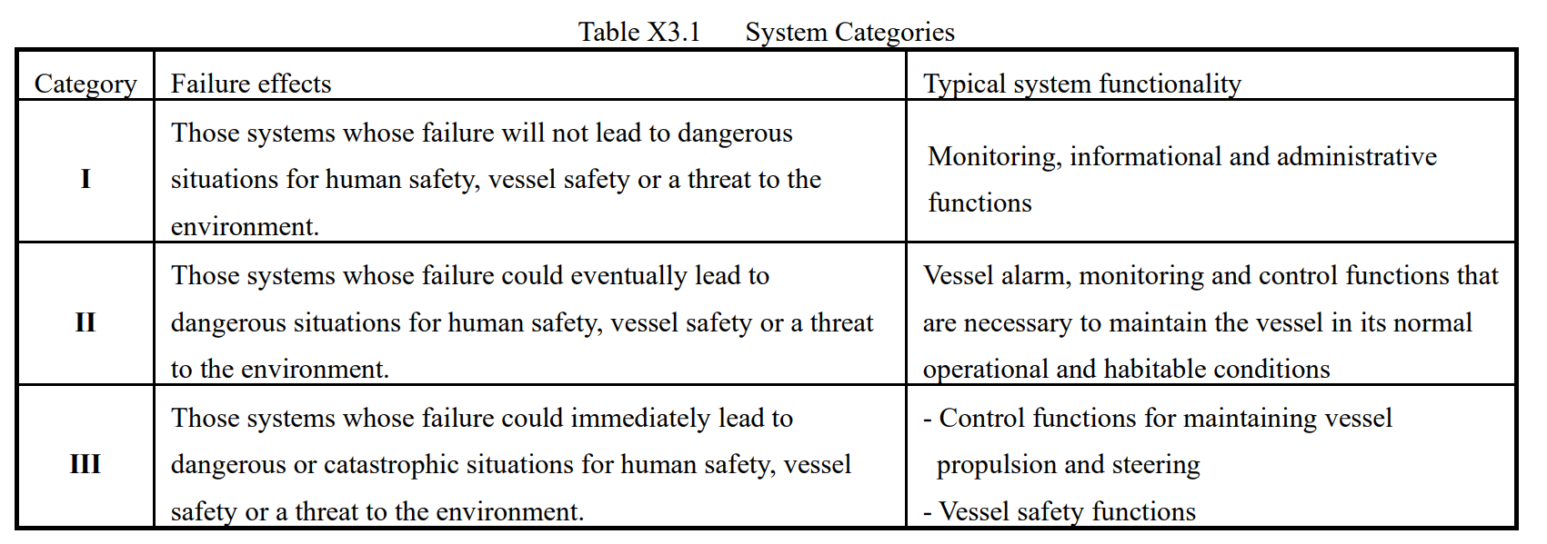
Category I systems are normally not subject to verification by the Society since a failure of such systems does not lead to dangerous situations. However, information pertinent to Category I systems is to be provided upon request to determine the correct category and ensure that they do not influence the operation of Category II and III systems.

(Chapter1 Branch 2 Computer-based system within the scope)
포함되는 system의 범위
A computer-based system is a programmable electronic device or interoperable set of
programmable electronic devices that are organised to achieve one or more specified purposes such
as the collection, processing, maintenance, use, sharing, dissemination, or disposition of information.
A programmable electronic device is a physical component in which software is installed and
includes a programmable logic controller (PLC).

The following are examples of computer-based systems that may be considered to fall within the scope of application of UR E27.
Please note that these are only examples, and
systems may otherwise be deemed applicable or non-applicable regardless of the table below.

Propulsion
Engine control systems

Engine remote control systems
Main boiler control systems
CPP control systems
Electric propulsion control systems
FGSS control systems
Machinery alarm and monitoring systems (including data loggers)
Waterjet propulsion systems
Engine telegraph

Steering
Steering system control systems
Azimuth thruster control systems

Anchoring and mooring
Windlass control systems
Mooring winch control systems

Electrical power generation and distribution
Generator engine control systems (including power management systems)
Electric power converters (for electric propulsion ship)

Battery management systems (consisting of lithium-ion batteries with total capacities of 20 kWh or more, and associated equipment)

Fire detection and extinguishing systems
Fire detection and alarm systems
Fixed foam fire extinguishing systems
Fixed CO2 fire extinguishing systems
Fixed deck foam systems
Fixed local application fire-fighting systems
Water-spraying systems
Dry chemical fire-extinguishing equipment

Bilge and ballast system, loading computer
Ballast transfer valve remote control systems
Loading computers

Watertight integrity and flooding detection
Watertight door power opening/closing devices
Water level detection and alarm systems

Lighting (e.g. emergency lighting, low locations, navigation lights, etc.)
Emergency lighting
Low location lighting
Navigation lighting control systems

Any required safety system whose disruption or functional impairing may pose risks
to ship operations (e.g. emergency shutdown system, cargo safety system, pressure
vessel safety system, gas detection system, etc.)
Inert gas systems
Cargo monitoring control systems
Liquefied gas emergency shutdown systems
Flammable gas detection systems
Reliquefication plants
Auxiliary boiler control systems
GCU control systems
Gas fuel tank monitoring and control systems

Navigational systems required by statutory regulations
Radar
Transmitting heading devices (THD)
Electronic plotting aids (EPA)
Automatic identification systems (AIS)
Automatic tracking aids (ATA)
Voyage date recorders (VDR)
Automatic radar plotting aids (ARPA)
Heading control systems (HCS)
Echo sounding devices
Track control systems (TCS)
Global navigation satellite systems (GPS)
Long range identification and tracking systems (LRIT)
Sound reception systems
Bridge navigational watch alarm systems (BNWAS)
Speed and distance measuring devices
Electronic chart display and information systems (ECDIS)
Electronic Inclinometer
Rate-of-turn indicator

Internal and external communication systems required by class rules and statutory regulations
General emergency alarm
Public addressor
NAVTEX receiver
VHF DSC device
EGC receiver
DSC device
VHF DSC continuous watch device
DSC continuous watch device
GMDSS radio installation

Others
Dynamic positioning systems (DPS)

2.3 Device in the same Security Zone as the applicable computer based system
(ClassNK Chapter1 Branch 3 Devices in the same security zone as the applicable
computer-based system)
어떤 부품이 어떤 security zone에 속할지 모름으로, Type approval을 받는 편이 낫다는 내용 추가
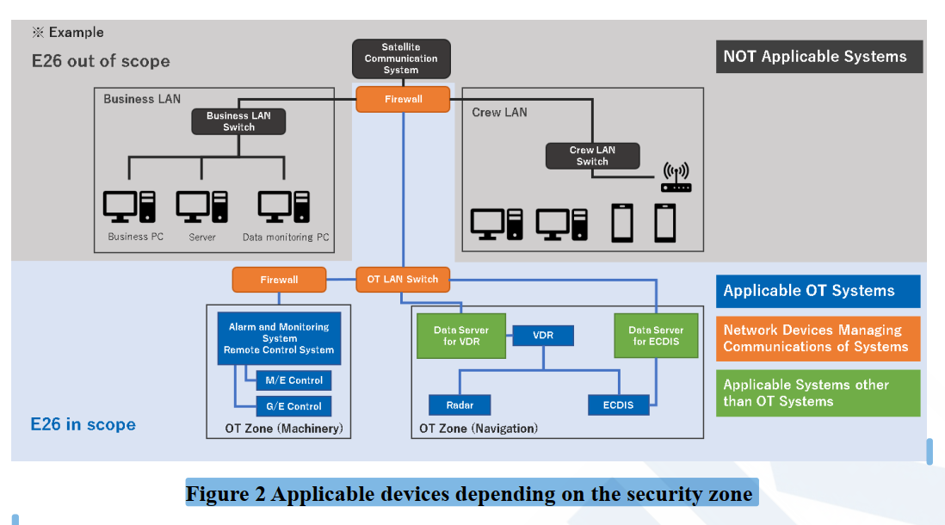
Figure 2 shows an example of the network configuration diagram covered according to Chapter 4 or 5, Part X (UR E26 or 27). As shown in Figure 2, this rule has the concept of a "security zone" formed by the applicable computer-based system described in Branch 2. A security zone is a group of onboard networks, consisting of one or more network segments that satisfying the same security policy. Zone boundary devices must be placed between different security zones. In this case, zone boundary device and network devices such as LAN switches shown in orange as in Figure 2, located on computer-based system side of those devices, and other systems shown in green as "Applicable systems other than the applicable computer-based system" that communicate directly with the applicable computer-based system without zone boundary device in between, and which are not designated as Branch 2 "computer systems included in the scope of application", are also applicable.
4.2.1 Security Zones and Network Segmentation
4.2.1.1 Requirement
All CBSs in the scope of applicability of this UR shall be grouped into security zones with
well-defined security policies and security capabilities. Security zones shall either be isolated
(i.e. air gapped) or connected to other security zones or networks by means providing control of data communicated between the zones (e.g. firewalls/routers, simplex serial links, TCP/IP
diodes, dry contacts, etc.)

2.4 Exclusion based on Risk assessment
(얘가 -> SoF Chapter1 Branch 4 Exclusion based on Risk assessment)

For computer-based systems described in Branch 2, if they are subject to the risk assessments required by Chapter 5, Part X (UR E26) and approved by the Society are excluded from Chapter 4, Part X (UR E27). Regarding the details of the risk assessment, please refer to the “Guidelines of Cyber Resilience of Ships” issued by the Society.

(PartX 5.5 Risk Assessment for Exclusion of Computer-based System from the Application of Requirements (5.5.4 Acceptance Criteria)
(1) The computer-based system is to be isolated (i.e, have no IP-network connections to other systems or networks).
(2) The computer-based system is to have no accessible physical interface ports. Unused interfaces are to be logically disabled. It is not to be possible to connect unauthorised devices to the computer-based system.
(3) The computer-based system is to be located in areas to which physical access is controlled.
(4) The computer-based system is not to be an integrated control system serving multiple ship functions as specified in the scope of applicability of this Chapter.

(1) The computer-based system should not serve ship functions of category III.
(2) Known vulnerabilities, threats, potential impacts deriving from a cyber incident affecting the computer-based system have been duly considered in the risk assessment.
(3) The attack surface for the computer-based system is minimized, having considered its complexity, connectivity, physical and logical access points, including wireless access points

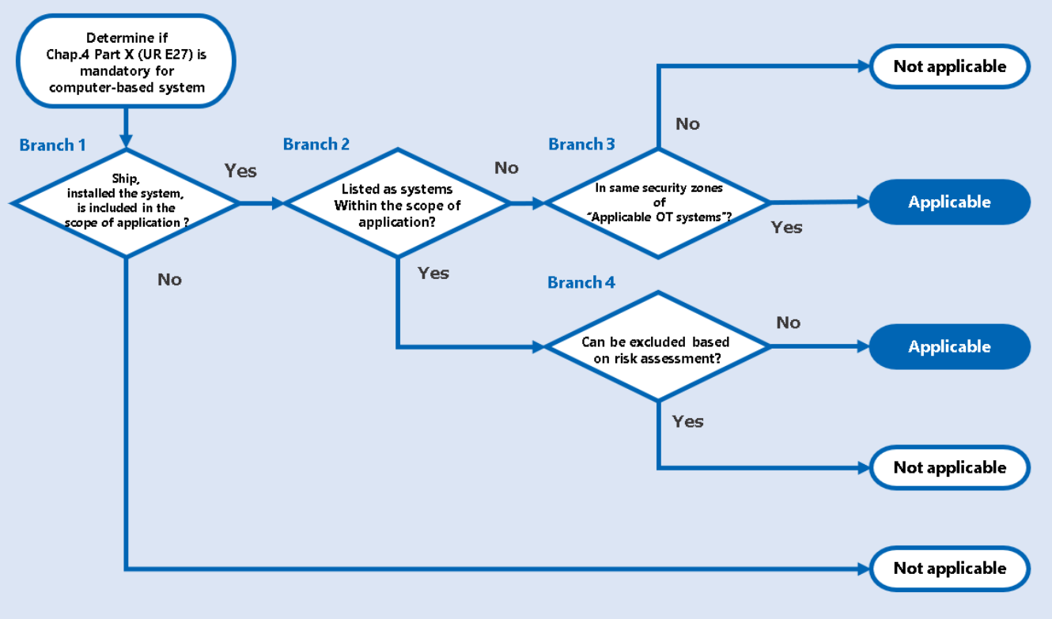

3. Definitions & Abbreviations

3.1. Definitions
(기본적으로 E27 1.4 Definitions & Abbreviations를 기준으로 작성 + E26에만 있는 용어들 + 문서상 추가로 필요한 부분)
Attack surface: The set of all possible points where an unauthorized user can access a
system, cause an effect on or extract data from. The attack surface comprises two categories:
digital and physical. The digital attack surface encompasses all the hardware and software
that connect to an organization’s network. These include applications, code, ports, servers and
websites. The physical attack surface comprises all endpoint devices that an attacker can gain
physical access to, such as desktop computers, hard drives, laptops, mobile phones,
removable drives and carelessly discarded hardware.
Authentication: Provision of assurance that a claimed characteristic of an identity is correct.
Compensating countermeasure: An alternate solution to a countermeasure employed in
lieu of or in addition to inherent security capabilities to satisfy one or more security
requirements.
Computer Based System (CBS): A programmable electronic device, or interoperable set of
programmable electronic devices, organized to achieve one or more specified purposes such
as collection, processing, maintenance, use, sharing, dissemination, or disposition of
information. CBS on-board include IT and OT systems. A CBS may be a combination of
subsystems connected via network. On-board CBS may be connected directly or via public
means of communications (e.g. Internet) to ashore CBSs, other vessels’ CBS and/or other
facilities.
Computer Network: A connection between two or more computers for the purpose of
communicating data electronically by means of agreed communication protocols.
Control: Means of managing risk, including policies, procedures, guidelines, practices or
organizational structures, which can be administrative, technical, management, or legal in
nature.
Cyber incident: An event resulting from any offensive cyber manoeuvre, either intentional or
unintentional, that targets or affects one or more CBS onboard, which actually or potentially
results in adverse consequences to an onboard system, network and computer or the
information that they process, store or transmit, and which may require a response action to
mitigate the consequences. Cyber incidents include unauthorized access, misuse,
modification, destruction or improper disclosure of the information generated, archived or
used in onboard CBS or transported in the networks connecting such systems. Cyber
incidents do not include system failures.
Cyber resilience: The capability to reduce the occurrence and mitigating the effects of
incidents arising from the disruption or impairment of operational technology (OT) used for the
safe operation of a ship, which potentially lead to dangerous situations for human safety,
safety of the vessel and/or threat to the environment.
Defence in depth: Information Security strategy integrating people, technology, and
operations capabilities to establish variable barriers across multiple layers and missions of
the organization.
Essential Systems: Computer Based System contributing to the provision of services
essential for propulsion and steering, and safety of the ship. Essential services comprise
"Primary Essential Services" and "Secondary Essential Services": Primary Essential Services
are those services which need to be in continuous operation to maintain propulsion and
steering; Secondary Essential Services are those services which need not necessarily be in continuous operation to maintain propulsion and steering but which are necessary for
maintaining the vessel’s safety.
Firewall: A logical or physical barrier that monitors and controls incoming and outgoing
network traffic controlled via predefined rules.
Firmware: Software embedded in electronic devices that provide control, monitoring and data
manipulation of engineered products and systems. These are normally self-contained and not
accessible to user manipulation.
Hardening: Hardening is the practice of reducing a system's vulnerability by reducing its
attack surface.
Information Technology (IT): Devices, software and associated networking focusing on
the use of data as information, as opposed to Operational Technology (OT).
Integrated system: A system combining a number of interacting sub-systems and/or
equipment organized to achieve one or more specified purposes.
Network switch (Switch): A device that connects devices together on a computer network,
by using packet switching to receive, process and forward data to the destination device.
Offensive cyber manoeuvre: Actions that result in denial, degradation, disruption,
destruction, or manipulation of OT or IT systems.
Operational technology (OT): Devices, sensors, software and associated networking that
monitor and control onboard systems. Operational technology systems may be thought of as
focusing on the use of data to control or monitor physical processes.
OT system: Computer based systems, which provide control, alarm, monitoring, safety
or internal communication functions.
Patches: Software designed to update installed software or supporting data to address
security vulnerabilities and other bugs or improve operating systems or applications
Protocols: A common set of rules and signals that computers on the network use to
communicate. Protocols allow to perform data communication, network management and
security. Onboard networks usually implement protocols based on TCP/IP stacks or various
field buses.
Recovery: Develop and implement the appropriate activities to maintain plans for resilience
and to restore any capabilities or services that were impaired due to a cyber security event.
The Recovery function support s timely return to normal operations to reduce the impact
from a cyber security event.
Supplier: A manufacturer or provider of hardware and/or software products, system
components or equipment (hardware or software) comprising of the application, embedded
devices, network devices, host devices etc. working together as system or a subsystem. The
Supplier is responsible for providing programmable devices, sub-systems or systems to the
System Integrator.
System: Combination of interacting programmable devices and/or sub-systems organized to
achieve one or more specified purposes.
System Categories (I, II, III): System categories based on their effects on system
functionality, which are defined in IACS UR E22.
System Integrator: The specific person or organization responsible for the integration of
systems and products provided by suppliers into the system invoked by the requirements in
the ship specifications and for providing the integrated system. The system integrator may
also be responsible for integration of systems in the ship. Until vessel delivery, this role shall
be taken by the Shipyard unless an alternative organization is specifically
contracted/assigned this responsibility.
Untrusted network: Any network outside the scope of applicability of this UR.

4. Approval Process
(ClassNK Chapter2 Approval Process)
기본적으로 Individual product approval(제품이 들어가는 배 마다 받는 인증 -> E27)
Type approval(부품 단위의 “사전 인증”-> 미리 E27 요구사항 충족 여부 확인)
2개의 approval이 존재하고
Individual의 경우
- type approval을 받은 경우,
(Document 간소화 + E27 Survey 생략 -> 제품 제작 과정에 대한 survey 생략
but, 선박 탑재 시의 survey는 받아야함 )
- type approval을 안 받은 경우,
(모든 Document 제출 + E27 Survey 필요)
- Sister vessel에 허가되어 장착된 경우
(모든 Document 제출 + E27 Survey 필요 but, 일부 문서 재사용 가능)

3가지 경우의 비교 요구 사항 비교 표 작성
Type Approval의 경우
- Approval Test
- Renewal Test
- Occassional Test 존재

For computer-based system to which this chapter applies, there are two types of approval: individual product approval and type approval. A summary of each type of approval is as follows.

Approval type
Individual product approval: This refers to product approval. Chapter 4, Part X (UR E27) applies to computer systems installed on applicable ships, and approval is required for each product.
Type approval: This refers to type approval. Part of the process required for individual product approval is eliminated by conducting the examinations and inspections of representative types specified in Chapter 4, Part X (UR E27) before it is prepared to be installed on board a ship

4.1 Individual product approval process
The process for approving an individual product is divided into several processes depending on whether the system has type approval and on the approval records for sister vessels. The overview of processes is as follows

System is not type approved:
In principle, all documentation and surveys are required.
System is type approved:
Some documentation may be omitted. In addition, surveys may also be omitted in lieu of the submission of “test reports”.
Previously approved system installed on sister vessel:
After comparing and examining any differences with the previously approved system, some or all documentation may be reused. The surveys are required.
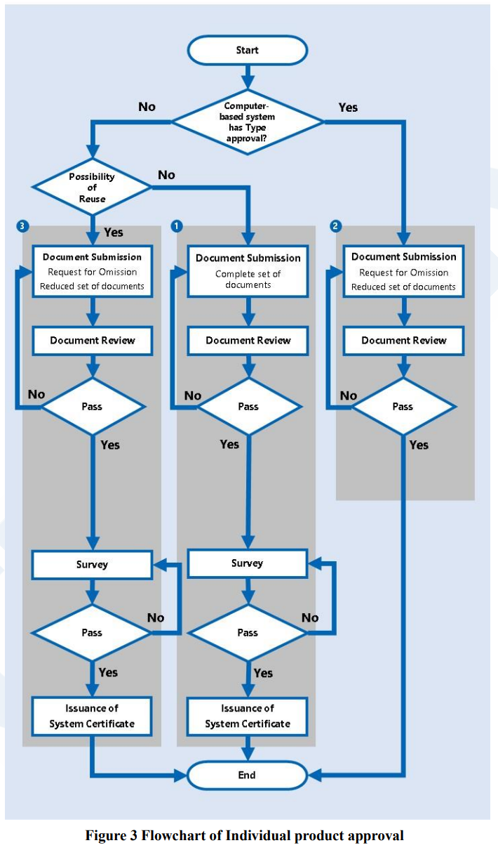
4.1.1 System is not type approved
In principle, all documentation must be submitted on a ship-by-ship basis for systems that are not approved for use. Please use NK-PASS to submit relevant documentation. Please refer to the following URL for more information on NK-PASS.
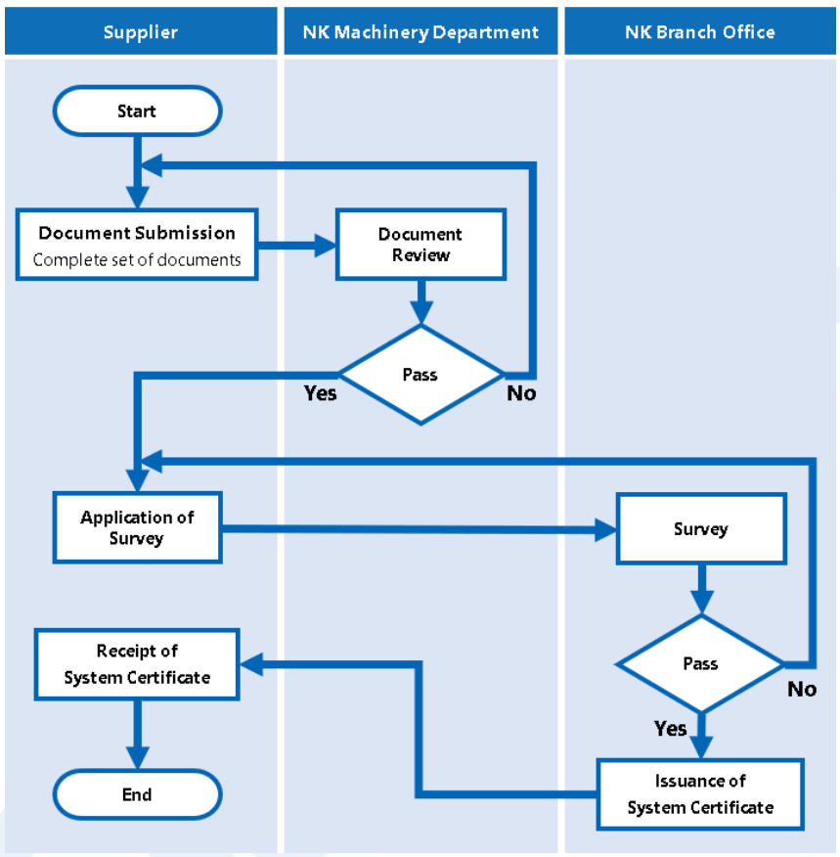
4.1.2 System is type approved
The submission of some of the required documents may be exempted for systems that are type approved. Applications for exemptions from submission of documents are to include the following information
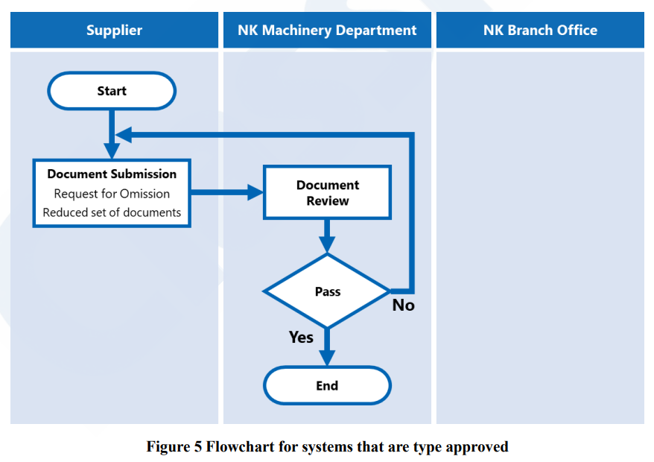

4.2 Type Approval process
In Section 2.1.1 of Rev.2, eight types of systems are listed as potentially vulnerable, forming the basis for identifying systems subject to cybersecurity risk. In contrast, Section 2.2.1 of Rev.3 expands this to nine systems, providing additional descriptions for each.
Notably, Rev.2 refers broadly to ‘communication systems’ for interaction with ports or shore-based facilities, whereas Rev.3 differentiates this category into ‘ship-port interfaces’ and ‘ship-to-shore integrated systems’, representing the most significant structural change in this section.

5. Requirements
The latest version of the IMO MSC ‘Guidelines on Maritime Cyber Risk Management’ specifies cybersecurity requirements incorporating IACS UR E26 and E27 standards and best practices. While it may not directly trigger an immediate revision of the IACS guidelines, the historical interplay between these regulatory frameworks indicates that a growing influence-reinforcing shipowners’ governance responsibilities, ensuring continued application of cyber resilience in vessels under operation, and increasing legal and financial risks tied to non-compliance.
Accordingly, it remains essential to continuously monitor updates to cybersecurity guidelines issued by major institutions such as IMO, IACS, NIST, and ISO. In parallel, a clear understanding of the timing and interpretation of implementation requirements by national classification societies is necessary to establish a proactive strategy aligned with the evolving level of cybersecurity expectations.

5.1 System Requirements
(ClassNK Chapter5) – system requirements 41개
(System req 30 + untrusted network용 additional 11개)
Section 4.2 of Rev.3 explicitly includes IACS UR E26 and UR E27 as part of the “additional standards that may

5.2 Secure Development Lifecycle requirements
(ClassNK Chapter6) – SDLC 7개

Section 4.2 of Rev.3 explicitly includes IACS UR E26 and UR E27 as part of the “additional standards that may

Contact Information
- Company & Department: EY Maritime Cyber Hub - KOREA
- Email: sang-woo.kim@kr.ey.com, insung.lee@kr.ey.com

6. Documents
The latest version of the IMO MSC ‘Guidelines on Maritime Cyber Risk Management’ specifies cybersecurity requirements incorporating IACS UR E26 and E27 standards and best practices. While it may not directly trigger an immediate revision of the IACS guidelines, the historical interplay between these regulatory frameworks indicates that a growing influence-reinforcing shipowners’ governance responsibilities, ensuring continued application of cyber resilience in vessels under operation, and increasing legal and financial risks tied to non-compliance.
Accordingly, it remains essential to continuously monitor updates to cybersecurity guidelines issued by major institutions such as IMO, IACS, NIST, and ISO. In parallel, a clear understanding of the timing and interpretation of implementation requirements by national classification societies is necessary to establish a proactive strategy aligned with the evolving level of cybersecurity expectations.

6.1 Computer Based System asset inventory
(ClassNK Chapter3) – Explanation of Documentation
societies is necessary to establish a proactive strategy aligned with the evolving level of cybersecurity

6.2 Topology diagrams
(ClassNK Chapter3) – system
societies is necessary to establish a proactive strategy aligned with the evolving level of cybersecurity

6.3 Description of Security capabilities
(ClassNK Chapter3) – system
societies is necessary to establish a proactive strategy aligned with the evolving level of cybersecurity

6.4 Test procedures of security capabilities
(ClassNK Chapter3) – system
societies is necessary to establish a proactive strategy aligned with the evolving level of cybersecurity

6.5 Security configuration guidelines
(ClassNK Chapter3) – system
societies is necessary to establish a proactive strategy aligned with the evolving level of cybersecurity

6.6 Secure development lifecycle
(ClassNK Chapter3) – system
societies is necessary to establish a proactive strategy aligned with the evolving level of cybersecurity

6.7 Plans for maintenance and verification
(ClassNK Chapter3) – system
societies is necessary to establish a proactive strategy aligned with the evolving level of cybersecurity

6.8 Information supporting incident response and recovery plans
(ClassNK Chapter3) – system
societies is necessary to establish a proactive strategy aligned with the evolving level of cybersecurity

6.9 Management of change plan
(ClassNK Chapter3) – system
societies is necessary to establish a proactive strategy aligned with the evolving level of cybersecurity

6.10 Test reports
(ClassNK Chapter3) – system
societies is necessary to establish a proactive strategy aligned with the evolving level of cybersecurity

7. References
The latest version of the IMO MSC ‘Guidelines on Maritime Cyber Risk Management’ specifies

오탈자 저작권, 문의사항 (27,28)

Appendix
- IMO Homepage: International Maritime Organization
- IMO MSC: Maritime Safety Committee (MSC)
- MSC.428(98) guideline: MSC 98-23-Add.1 - Report Of The Maritime Safety Committee OnIts Ninety-Eighth Session (Secretariat).pdf
- MSC-FAL.1/Circ.3/Rev.3 guideline: https://wwwcdn.imo.org/localresources/en/OurWork/Facilitation/FAL%20related%20nonmandatory%20documents/MSC-FAL.1-Circ.3-Rev.3.pdf
- MSC-FAL.1/Circ.3/Rev.1 guideline: https://wwwcdn.imo.org/localresources/en/OurWork/Facilitation/Facilitation/MSC-FAL.1-Circ.3-Rev.1%20-%20Guidelines%20On%20Maritime%20Cyber%20Risk%20Management%20%28Secretariat%29.pdf
- MSC-FAL.1/Circ.3/Rev.2 guideline: https://wwwcdn.imo.org/localresources/en/OurWork/Security/Documents/MSC-FAL.1-Circ.3-Rev.2%20-%20Guidelines%20On%20Maritime%20Cyber%20Risk%20Management%20%28Secretariat%29%20%281%29.pdf
- BIMCO Homepage: https://www.bimco.org/
- BIMCO’s ‘The Guidelines on Cyber Security Onboard Ships’ version 4: https://www.bimco.org/products/publications/titles/the-guidelines-on-cyber-security-onboard-ships/
- BIMCO’s ‘The Guidelines on Cyber Security Onboard Ships’ version 5: Updated: Guidelines on cyber security onboard ships
- IACS Homepage: Safer and Cleaner Shipping - IACS
- IACS UR E26 current version download page: UR E26 New - Withdrawn - Safer and Cleaner Shipping - IACS
- IACS UR E27 current version download page: UR E27 Rev1 - Safer and Cleaner Shipping - IACS
- The NIS 2 Directive guideline: https://www.nis-2-directive.com/

EY | Building a better working world

EY exists to build a better working world, helping to create long-term value for clients, people and society and build trust in the capital markets.

Enabled by data and technology, diverse EY teams in over 150 countries provide trust through assurance and help clients grow, transform and operate.

Working across assurance, consulting, law, strategy, tax and transactions, EY teams ask better questions to find new answers for the complex issues facing our world today.

EY refers to the global organization, and may refer to one or more, of the member firms of Ernst & Young Global Limited, each of which is a separate legal entity. Ernst & Young Global Limited, a UK company limited by guarantee, does not provide services to clients. Information about how EY collects and uses personal data, and a description of the rights individuals have under data protection legislation are available via ey.com/privacy. EY member firms do not practice law where prohibited by local laws. For more information about our organization, please visit ey.com.

ⓒ 2025 EY Consulting, Ltd.
All Rights Reserved.

This material has been prepared for general informational purposes only and is not intended to be relied upon as accounting, tax, legal or other professional advice. Please refer to your advisors for specific advice.

